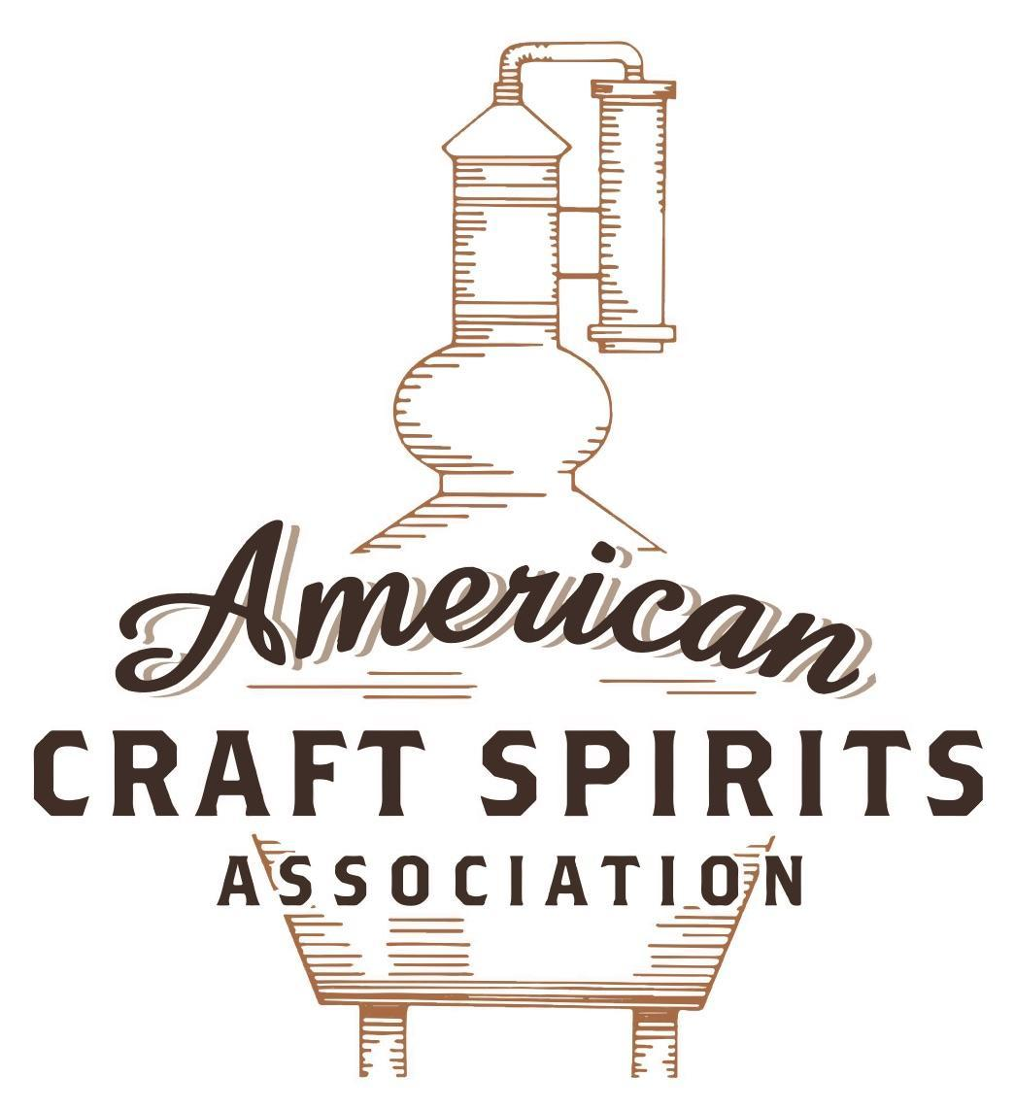
Spirits DtC Shipping Guide

This guide summarizes the direct-to-consumer shipping rules for distilleries in all 50 states and D.C. and also addresses the measures state governments have taken to ease delivery and shipping restrictions during the COVID-19 pandemic.

DtC Quick Guide Comparison

Out-of-State Distilleries  Can Ship Into State? |  |  |  | In-State Distilleries  Can Ship Within State?
State | Yes | No |  | State | Yes | No
AL |  | X |  | AL |  | X
AK | X |  |  | AK | X
AZ | X |  |  | AZ | X
AR |  | X |  | AR |  | X
CA |  | X* |  | CA |  | X*
CO |  | X |  | CO |  | X
CT |  | X* |  | CT |  | X
DE |  | X |  | DE |  | X
DC | X |  |  | DC | X
FL |  | X |  | FL |  | X
GA |  | X |  | GA |  | X
HI |  | X* |  | HI |  | ?*
ID |  | X |  | ID |  | X
IL |  | X* |  | IL |  | X*
IN |  | X |  | IN |  | X
IA |  | X* |  | IA |  | X*
KS |  | X |  | KS |  | X
KY | X |  |  | KY | X
LA |  | X |  | LA |  | X
ME |  | X* |  | ME |  | X*
MD |  | X |  | MD |  | X
MA |  | X |  | MA |  | X
MI |  | X |  | MI |  | X
MN |  | X |  | MN |  | X
MS |  | X |  | MS |  | X
MO |  | X |  | MO |  | X
MT |  | X |  | MT |  | X
NE | X |  |  | NE | X
NV |  | X* |  | NV |  | X
NH | X |  |  | NH |  | X*
NJ |  | X* |  | NJ |  | X*
NM |  | X |  | NM |  | X
NY |  | X* |  | NY |  | X*
NC |  | X |  | NC |  | X
ND | X |  |  | ND | X
OH |  | X |  | OH |  | X
OK |  | X |  | OK |  | X
OR |  | X |  | OR | X
PA |  | X* |  | PA |  | X
RI |  | X* |  | RI |  | X
SC |  | X |  | SC |  | X
SD |  | X |  | SD |  | X
TN |  | X |  | TN |  | X
TX |  | X |  | TX |  | X
UT |  | X |  | UT |  | X
VT |  | X |  | VT |  | X
VA |  | X |  | VA |  | X
WA |  | X* |  | WA | X
WV |  | X* |  | WV |  | X*

WI |  | X |  | WI |  | X
WY |  | X |  | WY |  | X

Notes:
*CA: If passed and signed into law, Senate Bill 620 would allow licensed distilled spirits producers in states other than California and licensed distilled spirits manufacturers or craft distillers in California who obtain distilled spirits direct shipper permits to ship directly to consumers in California
*CT: Consumers with appropriate permit may receive alcohol shipments
*HI: Consumers with appropriate permit may receive alcohol shipments; If passed and signed into law, Senate Bill 65 would allow licensed distilled spirits manufacturers in Hawaii and in states other than Hawaii who obtain direct shipper permits to ship directly to consumers in Hawaii
*IL: If passed and signed into law, Senate Bill 0532 would allow licensed distilled spirits producers in Illinois and in states other than Illinois who obtain distillery shippers’ licenses to ship directly to consumers in Illinois
*IA: If passed and signed into law, House File 639 would allow native distilled spirits manufacturers in Iowa and in states other than Iowa who obtain direct shipper permits to ship directly to consumers in Iowa and to consumers in states other than Iowa
*ME: If passed and signed into law, Legislative Document 1358 would allow distilleries outside of Maine with current manufacturer licenses and distilleries licensed in Maine who obtain spirits direct shipper licenses to ship directly to consumers in Maine
*NJ: (1) If passed and signed into law, Assembly Bill 3167 would allow a craft distillery licensees to ship no more than 9 liters of distilled spirits to a consumer in New Jersey; (2) If passed and signed into law, Senate Bill 3020 would allow craft distillery licensees in New Jersey or in states other than New Jersey to ship no more than 20 liters of distilled spirits to a consumer in New Jersey via common carrier
*NV: Licensed individuals can import one gallon per month of spirits for personal use and the out-of-state supplier must pay excise tax
*NH: If passed and signed into law, Senate Bill 125 would allow licensed liquor manufacturers who obtain direct to consumer shipping permits from the commission to ship directly to consumers in New Hampshire
*NY: Consumer may import up to 90L of liquor per year for personal use without a license; If passed and signed into law, Assembly Bill 3275 would allow licensed liquor manufacturers in states other than New York and licensed distillers and farm distillers in New York to ship no more than thirty-six cases (no more than nine liters per case) of liquor to consumers in New York
*PA: Consumer may place a special liquor order and distiller must ship to a PLCB-operated store
*RI: Distiller can only ship to customer if order was personally placed by customer at distiller's premises
*WA: If passed and signed into law, House Bill 1432 would allow licensed spirits manufacturers in states other than Washington to ship spirits to consumers in Washington
*WV: Distilleries, mini-distilleries, or micro-distilleries licensed in West Virginia or a state other than West Virginia who obtain private direct shipper licenses to ship to a consumer in West Virginia, however the shipments must be made to a retail liquor outlet

NEW YORK
Shipment Outbound – Yes, if allowed by the importing jurisdiction’s laws (NY SLA Distillery Quick Reference).
Shipment Inbound – No, however, a consumer may import up to 90L of liquor per year for personal use without a license (Tax Bulletin AB-275).
Shipment intra-state – No, all distillers must sell to licensed permittees and farm distilleries can only sell to customers at the licensed premises (NY Alcoh Bev Ctrl L § 61.2-c.(b)(iii)).
COVID-19 Measures – NYSLA released guidance stating that licensees with off premises privileges may deliver alcoholic beverages to a customer using a common carrier. The container must be a closed container or the original, sealed container. The order must include a food item which is consistent with the food requirement of the license (e.g., a manufacturer without an on premises must include finger foods). These privileges expired on June 24, 2021.
Citation (shipment)
New York Alcoholic Beverage Control Law
§ 61. Distiller's licenses.
2-c. (a) A class D distiller's license, otherwise known as a farm distillery license, shall authorize the holder of such a license to operate a farm distillery at the premises specifically designated in the license:
(i) To manufacture liquor primarily from farm and food products, as defined in subdivision two of section two hundred eighty-two of the agriculture and markets law;
(ii) To put such liquor into containers of not more than one quart each, which containers shall then be sealed and to sell such liquor at wholesale, for resale, and to licensed farm wineries, farm cideries, farm breweries and other farm distilleries, wholesale and retail licensees, and permittees;
(iii) To sell at retail, for personal use, in such sealed containers;
(b)(i) Retail sales by a licensed farm distillery may be made only to customers who are physically present upon the licensed premises and such sale shall be concluded by the customer's taking, with him or her, of the sealed containers purchased by the customer at the time the customer leaves the licensed premises except as provided for in subparagraph (iv) of this paragraph;
(ii) Such retail sales shall not be made where the order is placed by letter, telephone, fax or e-mail, or where the customer otherwise does not place the order while the customer is physically present upon the premises of the licensed premises except as provided for in subparagraph (iv) of this paragraph;
(iii) Such retail sales shall not be made where the contemplated sale requires the licensee to transport or ship by common carrier, sealed containers of liquor to a customer
5. No distiller shall be engaged in any other business on the licensed premises. No distiller shall sell or agree to sell any liquor, alcohol or spirits to any wholesaler or any retailer who is not duly licensed under this article to sell liquor, alcohol or spirits at wholesale or retail at the time of such agreement and sale or sell or agree to sell any liquor, alcohol or spirits to persons outside the state except pursuant to the laws of the place of such sale or delivery.
Link: https://www.nysenate.gov/legislation/laws/ABC/61
Distillery Quick Reference
Can I distribute my own products out of state?
Terms of sales and distribution out of state are governed by the laws of the importing jurisdiction.
Link: https://sla.ny.gov/system/files/documents/2019/08/Distillery%20Quick%20Reference%20-%20FINAL%20-%208-7-19.pdf
Filing Requirements for Individuals Who Import Alcoholic Beverages for Personal Use
Tax Bulletin AB-275 (TB-AB 275)
Issue Date: October 16, 2012
Introduction
If you import or cause to be imported beer, wine, or liquor (other than small amounts) into New York State for your personal use, you are responsible for paying New York's excise tax.

As a general rule, you're required to file a tax return and pay excise tax on beer, wine, or liquor you import or cause to be imported into New York State. This bulletin explains the filing requirements that apply to:
- noncommercial importers of beer or wine, and
- individuals who hold a special license to import liquor into New York for personal use.
Special license
You may need to obtain a special license to import liquor for your personal use. A special license allows you to import liquors into New York State without posting a bond. These conditions apply:
- You must have a special license if you're importing between 90 and 360 liters of liquor during a one-year period.
- You must be at least 21 years old to obtain a special license.

To apply for a special license, file Form TP-125, Application for Temporary License to Import Liquors for Personal Use and Consumption.
You must pay the alcoholic beverages tax due on any imported liquors.
You may import less than 90 liters of liquor into New York during a one-year period for your personal use without being registered. In this case, use Form MT-39, Alcoholic Beverages Tax Clearance Return for Tax on Importation of Alcoholic Beverages into New York State for Personal Consumption, to report and pay the alcoholic beverages tax.
Link: https://www.tax.ny.gov/pubs_and_bulls/tg_bulletins/abt/filing_requirements_for_individuals.htm
Citation (COVID-19)
New York State Liquor Authority
Guidance on Restrictions for Licensees and To-Go & Delivery Sales in Response to COVID-19 Outbreak Effective 03/16/2020 – 06/24/2021 (and will not be further extended)
The State Liquor Authority offers the following guidance:
- Any on-premises licensee and any manufacturing licensee with on-premises retail privileges may sell for off-premises consumption any alcoholic beverages that it is able to sell for on premises consumption under the law.
  - For example, a tavern wine licensee may sell beer, wine, cider, mead, and wine product, but not liquor, and a farm winery may sell any New York State labeled wine, beer, cider, mead, or liquor, but not non-New York State products unless it has an on-premises license as well.
Can I deliver alcoholic beverages to a customer using a common carrier (FedEx, UPS, etc.)?
Yes, so long as you have off premises privileges pursuant to the law or guidance and are following the guidance. The container must be a closed container or the original, sealed container. The order must include a food item which is consistent with the food requirement of your license, e.g., a manufacturer without an on premises must include finger foods; a tavern must include soups, sandwiches, or the like, etc. Note again that the guidance does not modify any current privileges to sell for off premises, e.g., an on premises retailer’s ability to sell beer without inclusion or food, or a winery’s ability to ship direct to consumer without inclusion of food, etc.
Link: https://sla.ny.gov/Restrictions-in-Response-to-COVID-19

The American Craft Spirits Association (ACSA) is working diligently to give our members and industry partners relevant, current updates on statutes and regulations impacting production, sale and distribution of spirits. With the declaration of the novel coronavirus (COVID-19) in early 2020, many states have issued temporary policy changes or longer-term modernization of alcohol beverage laws. State statutes, regulations created by the state alcohol regulatory authority, as well as any other relevant guidance provided by such authorities (such as advisories, opinions, bulletins, etc.) were reviewed in creation of this document. No city or county ordinances were reviewed. Distillers should be aware that even in states where direct shipping is permissible, always remember to avoid shipping to dry counties. Please consult with your state guild or alcohol beverage authority for the most up-to-date information. This content is intended for educational and informational purposes only. ACSA's pro bono law firm of Malkin Law P.A. provided the core content found in this comprehensive overview of the spirits distribution after COVID-19. It was completed in August 2021 and will be updated regularly. If you have updates you would like to provide, please send to legislation@americancraftspirits.org or directly to the law firm at: ryan@malkin.law / malkin.law. Thank you.
A. 03275, introduced on January 22, 2021, would allow a holder of a license to manufacture liquor in any other state, who obtains an out-of-state direct shipper’s license, to ship via common carrier no more than thirty-six cases (no more than nine liters each case) of liquor produced by such license holder per year directly to a resident of New York who is at least 21 years of age for personal use (subject to limitations). The bill is in committee. Link: https://assembly.state.ny.us/leg/?default_fld=&bn=A03275&term=2021&Summary=Y&Actions=Y&Text=Y&Committee%26nbspVotes=Y&Floor%26nbspVotes=Y#A03275A
A. 03275, introduced on January 22, 2021, would allow a distillery license holder or a farm distillery license holder to ship via common carrier no more than thirty-six cases (no more than nine liters per case) of liquor produced by such distillery or farm distillery per year directly to a New York resident who is at least 21 years of age for personal use. The bill is in committee. Link: https://assembly.state.ny.us/leg/?default_fld=&bn=A03275&term=2021&Summary=Y&Actions=Y&Text=Y&Committee%26nbspVotes=Y&Floor%26nbspVotes=Y#A03275A

